
Online Food Ordering Web Application using Jenkins and GitHub
A REPORT SUBMITTED

By

S. Taruni Satya Sri M. Ashritha

324103282112 324103282080

T. Kushali K. Spoorthi

324103282118 325103282L08

Under the esteemed guidance of Dr. K. Purushotam Naidu

Associate Professor
Department of Computer Science and Engineering (AI&ML) Gayatri Vidya Parishad College of Engineering for Women(A)
[Approved by AICTE NEW DELHI]

[Accredited by National Board of Accreditation (NBA) for B. Tech. CSE, ECE & IT – valid from 2019-22 and 2022-25] [Accredited by National Assessment and Accreditation Council (NAAC) with A Grade-Valid from 2022-2027]
Kommadi, Madhurawada, Visakhapatnam – 530048


GAYATRI VIDYA PARISHAD COLLEGE OF ENGINEERING FOR WOMEN (A) DEPARTMENT OF COMPUTER SCIENCE AND ENGINEERING (AI&ML)

This is to certify that the Project report titled “Online Food Ordering Web Application” is a bonafide work of following II B.Tech I Semester students in the Department of Computer Science and Engineering(AI&ML), Gayatri Vidya Parishad College of Engineering for Women(A) during the academic year 2025-26.

S. TARUNI SATYA SRI M. ASHRITHA
324103282112 324103282080
T. KUSHALI K. SPOORTHI
324103282118 325103282L08

Signature of the Guide

Dr. K. Purushotam Naidu (Associate Professor)

TABLE OF CONTENTS

Abstract

Introduction 5-7

1.1 Overview of the project | - 5
1.2 Problem Statement | - 5
1.3 Objectives of this project | - 6
1.4 Features of the System | - 6-7

TECHNOLOGIES USED 8-14
  - HTML (HyperText Markup Language) 8-9
  - Cascading Style Sheets (CSS) 10
  - JavaScript 10
  - Git 11-12
  - GitHub 13
  - Docker 13
  - Jenkins 14
- SOURCE CODE 15-32
  - index.html 15-22
  - style.css 23-29
  - script.js 30-32
- OUTPUT SCREENS 33-35
- CONCLUSION 36
- REFERENCES 37

ABSTRACT

The Online Food Ordering System – “Amrutham Restaurant” is a web-based application designed to simplify and modernize the process of ordering food online. The main objective of this project is to provide customers with a convenient, user-friendly, and visually appealing platform to browse a restaurant’s menu, view food images, check prices, and place their orders digitally. The system eliminates the need for physical visits and long waiting times by offering instant access to restaurant menus and easy online ordering from any device with internet connectivity. The project focuses on building a static and responsive frontend interface using HTML, CSS, and JSON, styled to resemble an attractive digital menu card that displays food items along with their names, descriptions, images, and prices. Each item features a clear "Order Now" button, enhancing the user experience through simple and intuitive navigation. The layout is designed to be visually appealing, resembling a modern restaurant catalogue while maintaining simplicity and accessibility.

- INTRODUCTION

The Online Food Ordering Web Application is designed to simplify the process of ordering food from restaurants through a user-friendly web interface. In today’s fast-paced world, people prefer convenient and time-saving ways to order their favourite meals. This web application provides customers with the ability to browse various food items, view menus with prices, and place orders directly from their devices.

The system aims to bridge the gap between restaurants and customers by providing an easy-to- use platform for online food ordering. It eliminates the need for physical visits or phone calls to restaurants. The application’s frontend is developed using HTML, CSS, and JavaScript to create an interactive and responsive user experience. The backend (if used) handles order management and data processing, while Git and GitHub manage the version control system.

  - Overview of the project:

The Amrutham Restaurant Online Food Ordering Web Application is a simple and attractive website that displays a restaurant menu with images, descriptions, and prices of food items like biryani, pizza, and desserts. It is developed using HTML, CSS, and JSON for the frontend and deployed using Docker.

The project integrates Git, GitHub, and Jenkins to implement a CI/CD pipeline, automating the process of building and deploying the website whenever code is updated. This project demonstrates the use of DevOps tools for continuous integration, delivery, and containerized deployment of a web application.

  - Problem Statement:

In today’s fast-paced world, customers prefer convenient and quick ways to order food online without waiting in long queues or making phone calls. However, many small restaurants lack a digital platform to showcase their menu attractively and manage online orders efficiently.
The “Amrutham Restaurant Online Food Ordering System” aims to solve this problem by developing a simple, user-friendly web application that displays menu items with images, prices, and descriptions. The project also integrates DevOps tools like Git, Jenkins, and

Docker to automate the build and deployment process, ensuring faster updates and reliable delivery of the application.

  - Objectives of the project:
The objectives of Online Food Ordering:
    - To develop an online platform for food ordering.
    - To provide a simple and attractive user interface.
    - To reduce manual workload and waiting time.
    - To automate the deployment process using DevOps tools.
    - To ensure portability and scalability.
    - To provide flexibility for content management.
    - To demonstrate the integration of web development and DevOps practices.

  - Features of the System:

The Online Food Ordering System provides an easy and convenient way for customers to browse and order food online from Amrutham Restaurant.

Main Features:
- Interactive Menu Display –
- Shows food items with attractive images, names, and prices Interactive User Interface.
- The website is designed using HTML, CSS, and JavaScript for a simple yet visually appealing layout
- It displays the restaurant’s menu items:
  - Item name, Price, Food image, Description
- Users can easily scroll through the items as if viewing a digital menu card.

- The page includes a beautiful background image for a modern, restaurant-themed design.
- Search and Selection –
- Users can easily find and choose their favorite dishes.
- Menu data is stored in a JSON file (menu_data.json) that contains food items, names, images, and prices.
- Order Management –
- Allows users to add items to the order list and place orders smoothly.
- Two images were created: food-backend – for backend (Flask/Python or static JSON API)
- food-frontend / amrutham-restaurant – for frontend web page
- Docker ensures port mapping, isolation, and consistent deployment.
- Responsive Design –
- The website is simple, fast, and works well on different devices.
- Integrated with GitHub and Jenkins for automation.
- Whenever new code (like design change or new food item) is pushed to GitHub:
- Jenkins automatically fetches it
- Builds the Docker images
- Automated Deployment –
- The system uses Git, Jenkins, and Docker for easy and consistent updates.

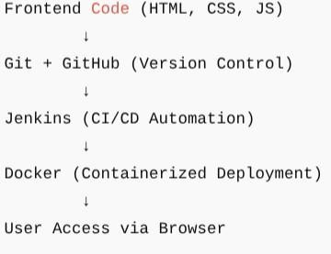
- TECHONOLOGIES

HTML (HyperText Markup Language):

HTML is the standard language used to create and structure web pages on the internet. It acts as the backbone of every website by defining the layout, content, and basic structure of a webpage. HTML uses a system of tags and elements to display text, images, buttons, links, forms, and other components in a browser

Fig 1: Structure of this web application

Why it is used?
In this project, HTML serves as the foundation layer on which CSS.
In this project, HTML serves as the foundation layer on which CSS styles the webpage to make it visually appealing, and JavaScript adds dynamic behaviour. Without HTML, the frontend of this food ordering app — including background images, menu display, and order form — would not exist. Therefore, HTML plays a crucial role in building a clean, user-friendly, and functional interface for customers to browse items and place orders easily.

online-food-app/
│
├── frontend/
│ ├── index.html
│ ├── style.css
│ ├── script.js
│ ├── images/
│ │ ├── bg.jpg
│ │ ├── biryani.jpg
│ │ ├── veg_biryani.jpg
│ │ ├── chocolate_icecream.jpg
│ │ ├── cake.jpg
│ │ ├── milkshake.jpg
│ │ ├── prawns.jpg
│ │ ├── pizza.jpg
│ │ ├── lollipop.jpg
│ │ ├── icecream_cake.jpg
│ │ ├── cold_coffee.jpg
│ ├── menu_data.json
│ ├── Dockerfile
│
├── .gitignore
├── Jenkinsfile
├── README.md

Cascading Style Sheets (CSS):

CSS (Cascading Style Sheets) is used in this project to make the food ordering website attractive, clean, and user-friendly.
While HTML creates the structure of the webpage, CSS adds styling like:

    - Background images

    - Colors and layout

    - Center alignment of menu items

    - Image sizes and rounded corners

    - Buttons (like Place Order)

    - Attractive categories layout

Without CSS, the website would look plain and unorganized. In this project, CSS helps present your food items neatly — similar to Swiggy or Zomato — making the user experience smooth and visually appealing.

JavaScript:

JavaScript brings dynamic functionality to the app. In this project, JavaScript is used to:

    - Load menu items from your menu_data.json

    - Show categories like Breakfast, Main Course, Snacks

    - Display images, prices, and details

    - Handle “Place Order” actions

    - Validate details like name, quantity, and address

    - Show a pop-up or confirmation message after order submission

JavaScript makes the webpage interactive, letting users actually place an order instead of just viewing items.

Git:

Git is the version control system used to track your project’s changes from the beginning to the end.
In this online food ordering app, Git helps you:

    - Save every update of HTML, CSS, JS, Dockerfile, Jenkinsfile

    - View history and restore old versions

    - Avoid losing work

    - Push your project to GitHub

    - Git makes teamwork and long-term project maintenance easy.

Git commands used:

# Initialize Git repository git init
# Configure user details

git config --global user.name "Your GitHub Username" git config --global user.email "your-email@example.com"

# To verify

git config –list

# Add all files to staging git add .

# Commit changes

git commit -m "Initial Commit – Adbutah Restaurant Online Food Ordering App" # Add remote repository
git remote add origin https://github.com/satyasri_05/online-food-app.git

# Push to GitHub

git push -u origin main #For Future Updates
git add .
git commit -m “Updated UI design and background image”

# To verify connection git remote -v
# Check current status git status
# Push changes to remote git push origin main
# View commit history git log --online

GitHub:

GitHub is the online platform where your Git repository is stored. For this project, GitHub allows you to:
    - Keep your project safe in the cloud
    - Share your code publicly or privately
    - Connect GitHub with Jenkins for automation
    - Show your project as a portfolio on LinkedIn
    - GitHub acts as your project’s hosting and collaboration platform.

Docker:

Docker is used to containerize the frontend application so that it runs the same way on any system.

In this project, Docker helps you:

    - Package HTML, CSS, JS, and images inside an Nginx container
    - Run your food ordering app using a single command
    - Avoid environment issues
    - Deploy easily through Jenkins

Using Docker, your food ordering app runs consistently and professionally, just like real production applications.

Jenkins:

Jenkins is used to create a CI/CD pipeline for automating the project. In this project, Jenkins:
    - Pulls code automatically from GitHub
    - Builds Docker images
    - Runs containers automatically
    - Tests if the app is running
    - Deploys the app without manual steps
    - Shows build logs and status

Jenkins makes your project automated, fast, and production-ready, just like real DevOps pipelines used in companies.

SOURCE CODE:

index.html

<!DOCTYPE html>

<html lang="en">

<head>

<meta charset="UTF-8">

<meta name="viewport" content="width=device-width, initial-scale=1.0">

<title>Adbutah Restaurant</title>

<link rel="stylesheet" href="style.css">

</head>

<body>

<header>

<h1>🍴 Adbutah Restaurant</h1>

<p>Delicious dishes, made with love and served fresh!</p>

</header>

<!-- Categories -->

<section class="menu-section">

<h2>🍛 Biryani Specials</h2>

<div class="menu-container">

<div class="menu-item">

<img src="images/biryani.jpg" alt="Chicken Biryani">

<h3>Chicken Biryani</h3>

<p>₹180</p>

<button onclick="openOrderForm('Chicken Biryani', 180)">Order</button>

</div>

<div class="menu-item">

<img src="images/veg_biryani.jpg" alt="Veg Biryani">

<h3>Veg Biryani</h3>

<p>₹150</p>

<button onclick="openOrderForm('Veg Biryani', 150)">Order</button>

</div>

<div class="menu-item">

<img src="images/prawns.jpg" alt="Prawns Fry">

<h3>Prawns Fry</h3>

<p>₹200</p>

<button onclick="openOrderForm('Prawns Fry', 200)">Order</button>

</div>

</div>

<h2>🍕 Fast Food</h2>

<div class="menu-container">

<div class="menu-item">

<img src="images/pizza.jpg" alt="Pizza">

<h3>Pizza</h3>

<p>₹160</p>

<button onclick="openOrderForm('Pizza', 160)">Order</button>

</div>

<div class="menu-item">

<img src="images/lollipop.jpg" alt="Chicken Lollipops">

<h3>Chicken Lollipops</h3>

<p>₹130</p>

<button onclick="openOrderForm('Chicken Lollipops', 130)">Order</button>

</div>

</div>

<h2>🍰 Desserts</h2>

<div class="menu-container">

<div class="menu-item">

<img src="images/icecream_cake.jpg" alt="Ice Cream Cake">

<h3>Ice Cream Cake</h3>

<p>₹120</p>

<button onclick="openOrderForm('Ice Cream Cake', 120)">Order</button>

</div>

<div class="menu-item">

<img src="images/chocolate_icecream.jpg" alt="Chocolate Ice Cream">

<h3>Chocolate Ice Cream</h3>

<p>₹80</p>

<button onclick="openOrderForm('Chocolate Ice Cream', 80)">Order</button>

</div>

<div class="menu-item">

<img src="images/cake.jpg" alt="Butterscotch Cake">

<h3>Butterscotch Cake</h3>

<p>₹100</p>

<button onclick="openOrderForm('Butterscotch Cake', 100)">Order</button>

</div>

</div>

<h2>☕ Beverages</h2>

<div class="menu-container">

<div class="menu-item">

<img src="images/cold_coffee.jpg" alt="Cold Coffee">

<h3>Cold Coffee</h3>

<p>₹70</p>

<button onclick="openOrderForm('Cold Coffee', 70)">Order</button>

</div>

<div class="menu-item">

<img src="images/milkshake.jpg" alt="Chocolate Milkshake">

<h3>Chocolate Milkshake</h3>

<p>₹90</p>

<button onclick="openOrderForm('Chocolate Milkshake', 90)">Order</button>

</div>

</div>

</section>

<!-- Popup Order Form -->

<div id="orderPopup" class="popup">

<div class="popup-content">

<span class="close" onclick="closeOrderForm()">&times;</span>

<h2>📝 Place Your Order</h2>

<form id="orderForm">

<input type="text" id="name" placeholder="Your Name" required><br>

<input type="text" id="address" placeholder="Delivery Address" required><br>

<input type="text" id="item" readonly><br>

<input type="text" id="price" readonly><br>

<input type="number" id="quantity" placeholder="Quantity" min="1" required><br>

<button type="submit">Place Order</button>

</form>

<p id="orderMessage"></p>

</div>

</div>

<footer>

<p>© 2025 Adbutah Restaurant | Made with ❤ for food lovers</p>

</footer>

<script>

const popup = document.getElementById('orderPopup'); const itemInput = document.getElementById('item'); const priceInput = document.getElementById('price');
const orderMessage = document.getElementById('orderMessage'); const form = document.getElementById('orderForm');
function openOrderForm(itemName, price) { itemInput.value = itemName; priceInput.value = "₹" + price; popup.style.display = 'flex';
}

function closeOrderForm() { popup.style.display = 'none'; form.reset(); orderMessage.textContent = '';
}

form.addEventListener('submit', (e) => { e.preventDefault();
orderMessage.textContent = "✅ Order placed successfully! Your delicious meal is on the way!";
form.reset();

});

window.onclick = function(event) { if (event.target === popup) { closeOrderForm();
}

}

</script>

</body>

</html>

style.css:

body { margin: 0;
font-family: 'Poppins', sans-serif;

background: linear-gradient(rgba(255, 255, 255, 0.88), rgba(255, 255, 255, 0.88)), url('bg.jpg');
background-size: cover; background-position: center; background-attachment: fixed; color: #333;
text-align: center;

}

header {

background-color: rgba(255, 140, 0, 0.85); color: white;
padding: 20px; font-size: 24px;

border-bottom: 4px solid #ff8800;

}

.menu-section h2 { margin-top: 40px; color: #e67e22; font-size: 28px;
}

menu-container { display: flex;
justify-content: center; flex-wrap: wrap;
gap: 20px; margin-top: 15px;
}

.menu-item {

background-color: rgba(255, 255, 255, 0.9); border-radius: 15px;

padding: 15px; width: 220px;
box-shadow: 0 4px 8px rgba(0,0,0,0.1); transition: transform 0.3s ease;
}

.menu-item:hover { transform: scale(1.05);
}

.menu-item img { width: 100%; height: 160px; object-fit: cover; border-radius: 12px;
}

.menu-item button { background-color: #e67e22; color: white;

border: none; padding: 8px 14px; border-radius: 8px; cursor: pointer; margin-top: 10px;
}

.menu-item button:hover { background-color: #cf711f;
}

.popup { display: none; position: fixed; top: 0; left: 0;
width: 100%; height: 100%;

background-color: rgba(0, 0, 0, 0.5); justify-content: center;
align-items: center;

z-index: 10;

}

.popup-content { background-color: #fff; padding: 25px;
border-radius: 15px; width: 300px;
text-align: center; position: relative;
}

.close {

position: absolute; top: 8px;
right: 12px; font-size: 24px; cursor: pointer;
}

.popup-content input { width: 90%; padding: 10px; margin: 8px 0; border-radius: 5px;
border: 1px solid #ccc;

}

.popup-content button { background-color: #e67e22; color: white;
border: none; padding: 10px 20px; font-size: 16px; border-radius: 8px; cursor: pointer;
}

popup-content button:hover {

background-color: #cf711f;

}

footer {

margin-top: 40px; padding: 15px;
background-color: rgba(255, 140, 0, 0.85); color: white;
}

Script.js:

const menuItems = [

{ name: "Chicken Biryani", price: 180, image: "images/biryani.jpg" },

{ name: "Veg Biryani", price: 150, image: "images/veg_biryani.jpg" },

{ name: "Pizza", price: 220, image: "images/pizza.jpg" },

{ name: "Ice Cream Cake", price: 100, image: "images/icecream_cake.jpg" },

{ name: "Cold Coffee", price: 90, image: "images/cold_coffee.jpg" },

{ name: "Chocolate Ice Cream", price: 80, image: "images/chocolate_icecream.jpg" },

{ name: "Chocolate Milkshake", price: 120, image: "images/milkshake.jpg" },

{ name: "Butterscotch Cake", price: 150, image: "images/cake.jpg" },

{ name: "Chicken Lollipops", price: 200, image: "images/lollipop.jpg" },

{ name: "Prawns Fry", price: 250, image: "images/prawns.jpg" }

];

const menuContainer = document.getElementById("menu"); const itemSelect = document.getElementById("itemSelect"); menuItems.forEach(item => {
const card = document.createElement("div");

card.classList.add("card"); card.innerHTML = `
<img src="${item.image}" alt="${item.name}">

<h3>${item.name}</h3>

<p>₹${item.price}</p> menuContainer.appendChild(card);
const option = document.createElement("option"); option.value = item.name;
option.textContent = item.name; itemSelect.appendChild(option);
});

document.getElementById("orderForm").addEventListener("submit", function(e) { e.preventDefault();
const name = document.getElementById("name").value; const address = document.getElementById("address").value; const quantity = document.getElementById("quantity").value; const item = document.getElementById("itemSelect").value;

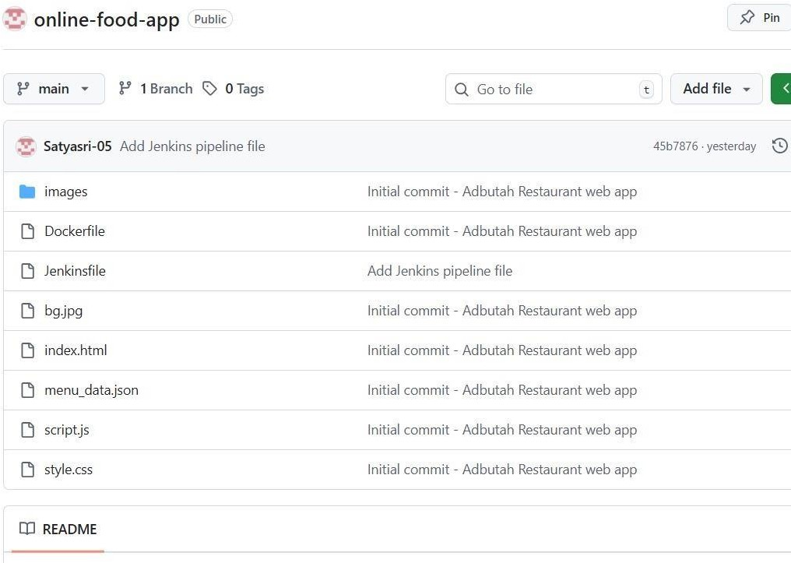
document.getElementById("orderMessage").textContent =

✅ Thank you ${name}! Your order for ${quantity} ${item}(s) will be delivered soon to ${address}.;

this.reset();

});

Fig 2: GitHub Repository of Online Food Ordering

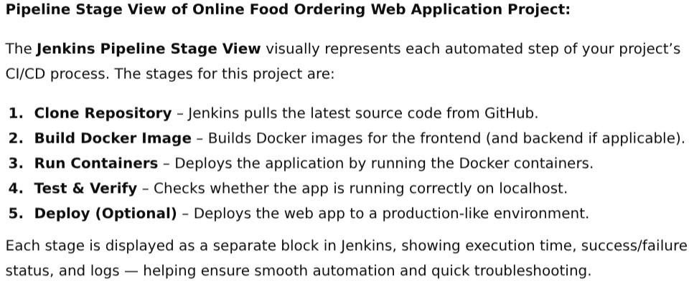
OUTPUT SCREENS

The output screen of the Online Food Ordering Web Application displays a clean, userfriendly webpage for Amrutham Restaurant, featuring a light background image and neatly arranged food categories. Each menu item shows its image, name and price along with a “Place Order” button. When clicked, users can enter their name, quantity, and address to confirm the order. The app runs smoothly through Docker, managed with Git and Jenkins for deployment automation.

Pipeline Job Configuration

The pipeline job configuration automates the building and deployment process of the Online Food Ordering Web Application using Jenkins. It pulls the source code from the GitHub repository, builds a Docker image for the application, runs the container, and verifies successful deployment. This setup ensures continuous integration and continuous deployment (CI/CD), making the process faster, reliable, and fully automated from code commit to deployment.

Fig 3: Pipeline stage view

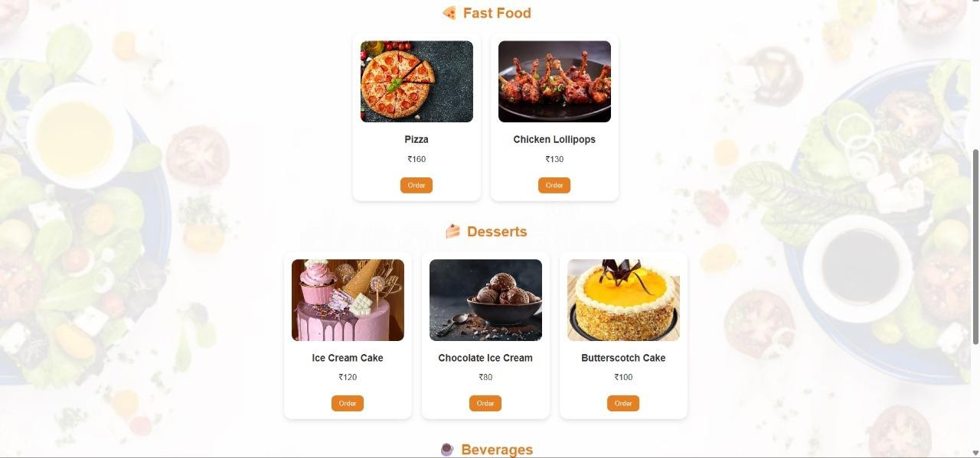
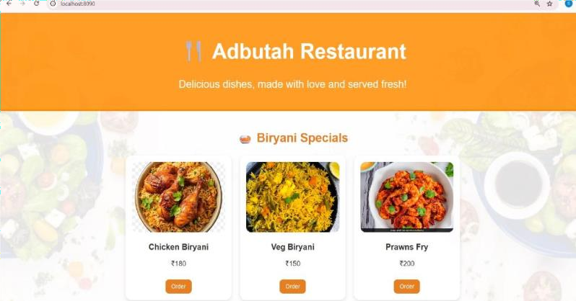
Docker Desktop Dashboard

The Docker Desktop dashboard displays the active container amrutham-container running the food ordering web app using the image amrutham-restaurant. The container is deployed on port 8080 and verified as successfully running, ensuring smooth deployment and accessibility of the web application.

Application Output

Fig 4: Live web page Application interface

Fig 5: Online Food Ordering webpage interface

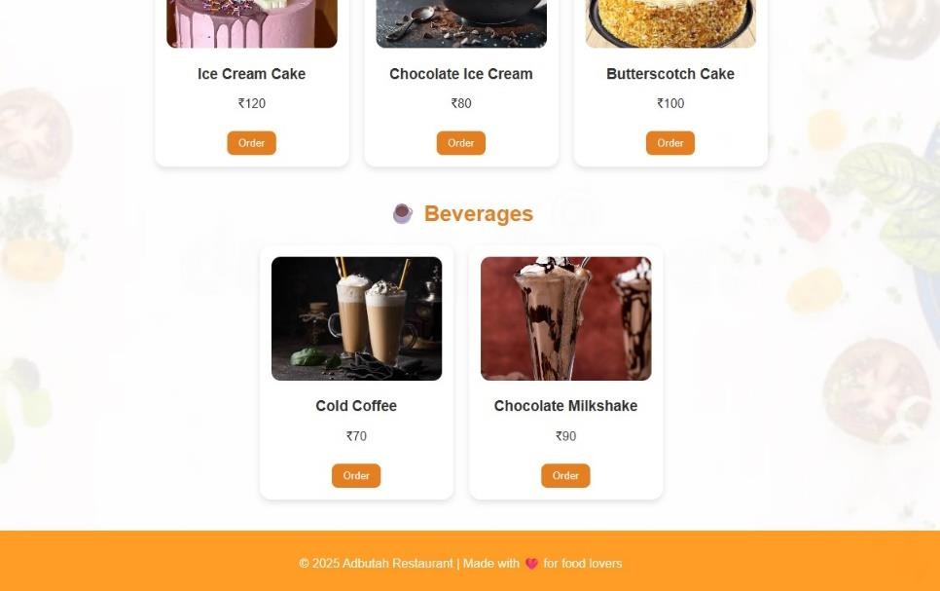
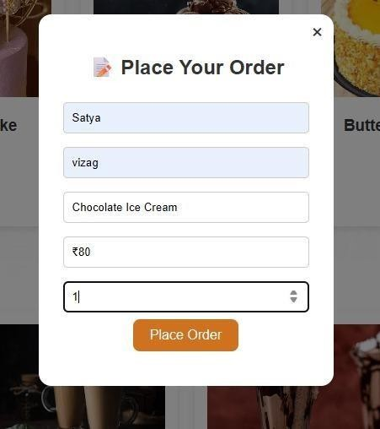

Fig 6: To select an item to place an order.

Fig 7: This is to place an order.

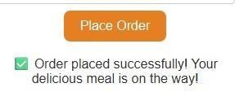

Fig 8: Placed order successfully.

- CONCLUSION

The Online Food Ordering Web Application project successfully demonstrates how modern web technologies and DevOps tools can be integrated to create an efficient and automated system. The application provides a simple, user-friendly interface for customers to browse menu items, view categories, and place food orders online — similar to popular platforms like Swiggy and Zomato.

By using HTML, CSS, and JavaScript for the frontend, the app delivers a responsive and visually appealing design. With the integration of Git, Jenkins, and Docker, the development process becomes more reliable through version control, continuous integration, and containerized deployment.
The final result is a lightweight, scalable, and easy-to-deploy web application that enhances customer convenience and demonstrates practical implementation of DevOps in real-world web development. This project not only meets the functional requirements of a food ordering system but also strengthens understanding of automation and deployment workflows in software development.

- REFERENCES
- Docker Documentation. "Get Started with Docker." Docker Inc. Available at: https://docs.docker.com/get-started/ [Accessed November 2025]. Official Docker documentation and tutorials.
- By using the sites like Google, ChatGpt…I explored more and prepared this web application more effectively.
- GitHub Documentation. "GitHub Docs." GitHub Inc. Available at: https://docs.github.com/ [Accessed November 2025]. GitHub features and integration documentation.

